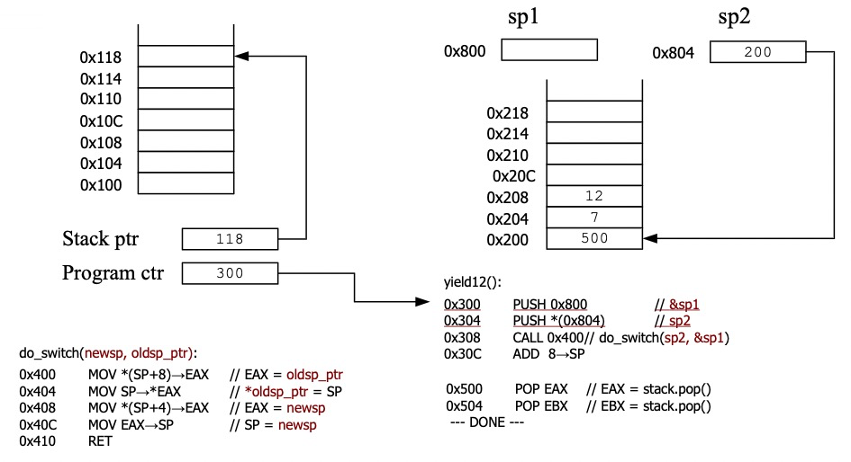

1. 0x300 PUSH 0x800

(Program Counter: 0x300; Instruction: PUSH 0x800; Changes: Stack Pointer = 0x114 \*(0x114) = &sp1 = 0x800)

1. 0x304 PUSH \*(0x804)

(Program Counter: 0x304; Instruction: PUSH \*(0x804); Changes: Stack Pointer = 0x110 \*(0x110) = \*(0x804) = 200)

1. 0x308 CALL 0x400

(Program Counter: 0x308; Instruction: CALL 0x400; Changes: Stack Pointer = 0x10C \*(0x10C) = 0x30C; Jumps to 0x400)

④ 0x400 MOV \*(SP+8) → EAX

(Program Counter: 0x400; Instruction: MOV \*(SP+8) → EAX; Changes: EAX = 0x800)

⑤ 0x404 MOV SP → \*EAX

(Program Counter: 0x404; Instruction: MOV SP → \*EAX; Changes: \*(0x800) = 0x10C)

⑥ 0x408 MOV \*(SP+4) → EAX

(Program Counter: 0x408; Instruction: MOV \*(SP+4) → EAX; Changes: EAX = 0x200)

⑦ 0x40C MOV EAX → SP

(Program Counter: 0x40C; Instruction: MOV EAX → SP; Changes: Stack Pointer = 0x200)

⑧ 0x410 RET

(Program Counter: 0x410; Instruction: RET; Changes: Program Counter = 0x500 Stack Pointer = 0x204; Jumps to 0x500)

⑨ 0x500 POP EAX

(Program Counter: 0x500; Instruction: POP EAX; Changes: EAX = 7 Stack Pointer = 0x208)

⑩ 0x504 POP EBX

(Program Counter: 0x504; Instruction: POP EBX; Changes: EBX = 12 Stack Pointer = 0x20C)